**1. Write a simple Source code for following HTML Webpage?**

<html lang="en">

<!DOCTYPE html>

<html lang="en">

<head>

<meta charset="UTF-8">

<meta name="viewport" content="width=>, initial-scale=1.0">

<title>Document</title>

<link rel="stylesheet" href="https://cdnjs.cloudflare.com/ajax/libs/fontawesome/6.4.0/css/all.min.css" integrity="sha512iecdLmaskl7CVkqkXNQ/ZH/XLlvWZOJyj7Yy7tcenmpD1ypASozpmT/E0iPtmFIB46ZmdtAc9eNBvH0H/Z piBw=="

crossorigin="anonymous" referrerpolicy="no-referrer" />

<link rel="stylesheet" href="example_1.css">

</head>

<body>

<div id="main">

<div id="header"> ibrahim </div>

<div id="content">

] <div id="c1">

<img src="images1.png" width="100" height="100"> <br>

<ul>

<li style="background-color: aqua;width: 100px; ">Home</li>

<br>

<ul type="square">

<ul type="square"></ul>

<li>Career</li>

<br>

<li>Contact</li>

<br>

<li>About</li>

</ul><br><br>

<p>"do scmething important in life i convent green grass to code" </p>

<br>

<h6>-mr ibrahim</h6>

</div>

<div id="c2">

<h3>

<b>About Me</b>

</h3><br>

My self Mr.ibrahim.

I am a Developer.

I Work in Multi national Company.

<br><br>

<h3>

WEB DESIGNING

</h3><br>

I work as a web developer for a company that makes website for car businesses.

<br>

<hr>

<pre>

</pre>

</div>

<h3>

<b>How Can I help You?</b>

</h3><br>

<div id="f1">

skill 1

<br>

<div id="r1">

<i class="fa-solid fa-paintbrush"></i>

<br>

<div id="f3">

kakus in your backyard

</div>

</div>

</div>

<div id="f2">

skill 2

<br>

<div id="r1">

<i class="fa-sharp fa-solid fa-trash"></i> <br>

</div>

<div id="f6">

storing some fat for you <br>

</div>

</div>

<div id="f5"> skill 3 <br>

<div id="r8"> <i class="fa-solid fa-truck-fast"></i>

<div id="f9">

<br> laking you throught the desert

</div>

</div>

</div><br><br><br><br>

<div class="information"> Email. <input type="email" placeholder="enter the Email">

<br> mobile: <input type="tel" id="phone" name="phone" pattern="[0-9]{3}-[0-9]{3}-[09]{4}"

placeholder="123-456-7890"><br>

<input type="text" placeholder="Enter your message.."><br>

<button>Submit</button>

<button>reset</button>

</div> <br><br>

<footer>

<p>& copyright ibrahim burhanpurwala</p>

<p>enrolement no. 2202020101083</p>

</footer>

</body>

</html>

**css page**

.page * {

padding: 0px;

margin: 0px;

}

#main {

border: 1px solid white;

width: auto auto;

}

#header {

font-size: 30px;

textalign: left;

font-family: 'Franklin Gothic Medium', 'Arial Narrow', Arial, sans-serif border 0px solid blue;

width: auto;

height: 50px;

height: background-color darkgray;

}

#content {

border: 1px solid white;

width: auto 350px;

}

#c1 {

border: 1px solid white;

width: 150px;

height:

380px;

float: left;

}

#f1 {

background-color: aqua;

border: 1px solid darkgray;

width: 280px;

height:

17px;

float: left;

}

#r1 {

text-align: center;

border: 1px solid darkgray height width280px;

height: 17px;

float: left;

}

#f3 {

border: 1px solid darkgray;

width: 280px;

height:

17px;

float: left;

}

#f2 {

background-color: aqua;

border: 1px solid darkgray;

width: 280px;

height:

17px;

float: left;

}

#f6 {

border: 1px solid darkgray;

width: 280px;

height: 17px;

float: left;

}

#f5 {

background-color: aqua;

border: 1px solid darkgray;

width: 280px;

height: 17px;

float: left;

}

#r8 {

text-align: center;

border: 1px solid darkgrey;

width: 280px;

height: 17px;

float: left;

}

#f9 {

border: 1px solid darkgrey;

width: 280px;

height: 17px;

float: left;

}

footer {

height: 60px;

background-color: rgb(19, 19, 21);

color: white;

text-align: center;

}

.hemant {

text-align: end;

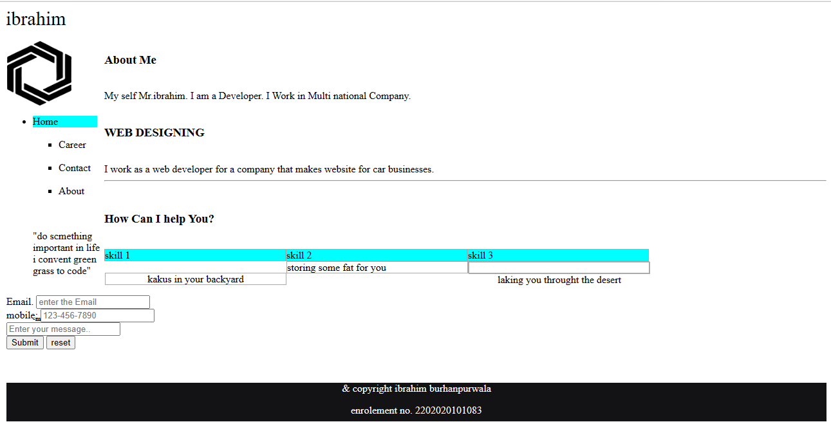

**­­**

**2. Design and write Leave Application Using HTML code?**

<!DOCTYPE html>

<html lang="en">

<head>

<meta charset="UTF-8">

<meta name="viewport" content="width=>, initial-scale=1.0">

<title>Document</title>

<link rel="stylesheet" href="example_2.css">

</head>

<body>

<p>

<pre style="color:brown;">To</pre>

<pre style="text-align: right ; color: brown;"> Date:10/11/2021</pre>

<pre style="color: brown;">The Manager, Wipro Technologies. Banglore </pre>

</p>

<p style="color: chartreuse;">From<br>

Ibrahim Burhanpurwala,<br> Employee ID:1254.<br> developer,<br> It Department.<br> </p>

<p>

<h4 style="margin-left: 150px;color: darkblue;">Subject:Application for Leave</h4>

</p>

<p style="color: burlywood;"> Dear Sir/Madam, </p>

<pre

style="color: brown;"> i am writing this letter to inform and to get permission to

take a 5 days of leave starting from <b style="color: gray;">11/05/2021 to15/05/2021</b> because of some personal. reasons.</pre>

<code style="color: brown;">

i hope you will understand myn situation and grant me level for 5 days.i

will return to the work immediately after the leavel i.e.<b style="color: gray;"> on 16/05/2021</b>.</code>

<code style="color: brown;">in case of any emergency.i will avaliable on my mobile.</code>

<code style="color: brown; ">in shall be obuged to you in this matter.</code>

<code style="margin-left:100px;color: brown;">Thanking you,</code>

<code style="margin-left:450px;color: brown;">sincerely<br>ibrahim

.<br>9316296844</code>

<footer>

<p>& copyright ibrahim burhanpurwala</p>

<p>enrolement no. 2202020101083</p>

</footer>

</body>

</html>

**css file**

footer {

height: 60px;

background-color: rgb(19, 19, 21);

color: white;

textalign: center;

}

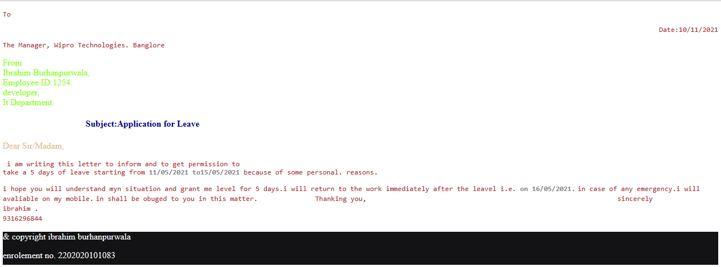

**3. Write a code for Calculator and perform Basic arithmetic Operation like (+, -, *, /, =) Using CSS and JavaScript**

<!DOCTYPE html>

<html>

<head>

<meta charset="utf-8">

<title>

Calculator using HTML Example

</title>

<link href="https://fonts.googleapis.com/css2?family=Cookie&display=swap" rel="stylesheet">

<!-- CSS property to create interactive

calculator interface -->

<style>

body {

background-color: tan;

}

.box {

background-color: #3d4543;

height: 300px;

width: 270px;

border-radius: 10px;

position: relative;

top: 80px;

left: 40%;

}

.display {

background-color: #222;

width: 220px;

position: relative;

left: 15px;

top: 20px;

height: 40px;

}

.display input {

position: relative;

left: 2px;

top: 2px;

height: 35px;

color: black;

background-color: #bccd95;

font-size: 21px;

text-align: right;

}

.keys {

position: relative;

top: 15px;

}

.button {

width: 40px;

height: 30px;

border: none;

border-radius: 8px;

margin-left: 17px;

cursor: pointer;

border-top: 2px solid transparent;

}

.button.gray {

color: black;

color: black;

background-color: #6f6f6f;

border-bottom: black 2px solid;

border-top: 2px #6f6f6f solid;

}

.title:hover {

color: #fff;

}

.title {

margin-bottom: 10px;

margin-top: 30px;

padding: 5px 0;

font-size: 40px;

font-weight: bold;

text-align: center;

color: black;

font-family: 'Cookie', cursive;

}

.button.pink {

color: black;

background-color: #ff4561;

border-bottom: black 2px solid;

}

.button.black {

color: black;

background-color: 303030;

border-bottom: black 2px solid;

border-top: 2px 303030 solid;

font-weight: bold;

}

.button.orange {

color: black;

background-color: FF9933;

border-bottom: black 2px solid;

border-top: 2px FF9933 solid;

}

.gray:active {

border-top: black 2px solid;

border-bottom: 2px #6f6f6f solid;

}

.pink:active {

border-top: black 2px solid;

border-bottom: #ff4561 2px solid;

}

.black:active {

border-top: black 2px solid;

border-bottom: #303030 2px solid;

}

.orange:active {

border-top: black 2px solid;

border-bottom: FF9933 2px solid;

}

p {

line-height: 10px;

}

footer {

height: 60px;

background-color: rgb(19, 19, 21);

color: white;

text-align: center;

}

</style>

</head>

<body>

<div class="title? align=" centre">

<pre

style="font-family: 'Gill Sans', 'Gill Sans MT', Calibri, 'Trebuchet MS', sans-serif;text-align: center ;">calculator</pre>

</div>

<div class="box">

<div class="display">

<input type="text" readonly size="18" id="d">

</div>

<div class="keys">

<p> <input type="button" class="button gray" value="mrc" onclick='c("Created....................")'>

<input type="button" class="button gray" value="m-" onclick='c("...............by............")'>

<input type="button" class="button gray" value="m+" onclick='c(".....................Anoop")'>

<input type="button" class="button pink" value="/" onclick='v("/")'>

</p>

<p> <input type="button" class="button black" value="7" onclick='v("7")'>

<input type="button" class="button black" value="8" onclick='v("8")'>

<input type="button" class="button black" value="9" onclick='v("9")'>

<input type="button" class="button pink" value="*" onclick='v("*")'>

</p>

<p> <input type="button" class="button black" value="4" onclick='v("4")'>

<input type="button" class="button black" value="5" onclick='v("5")'>

<input type="button" class="button black" value="6" onclick='v("6")'>

<input type="button" class="button pink" value="-" onclick='v("-")'>

</p>

<p> <input type="button" class="button black" value="1" onclick='v("1")'>

<input type="button" class="button black" value="2" onclick='v("2")'>

<input type="button" class="button black" value="3" onclick='v("3")'>

<input type="button" class="button pink" value="+" onclick='v("+")'>

</p>

<p> <input type="button" class="button black" value="0" onclick='v("0")'>

<input type="button" class="button black" value="." onclick='v(".")'>

<input type="button" class="button black" value="C" onclick='c("")'>

<input type="button" class="button orange" value="=" onclick='e()'>

</p>

</div>

</div>

<footer>

<p>& copyright ibrahim burhanpurwala</p>

<p>enrolement no. 2202020101083</p>

</footer>

</body>

<script>

function c(val) {

document.getElementById("d").value = val;

}

function v(val) {

document.getElementById("d").value += val;

}

function e() {

try {

c(eval(document.getElementById("d").value))

}

catch (e) {

c('Error')

}

}

</script>

</html>

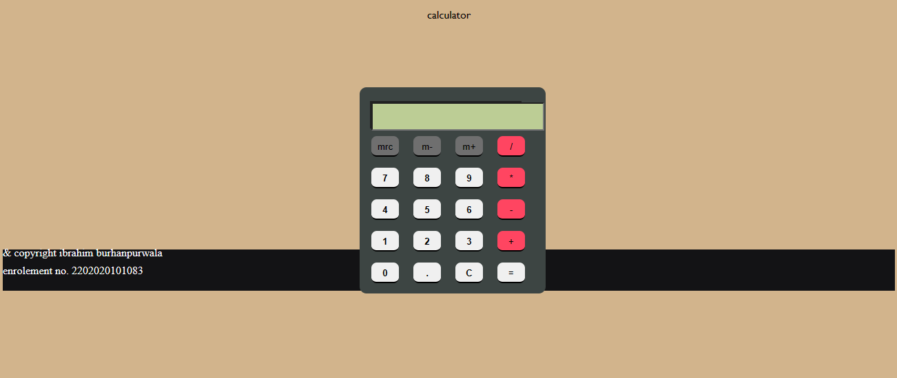

**4. Write a HTML code for Create Relevant Class Time Table?**

<!DOCTYPE html>

<body>

<style>

table,

td,

th,

tr {

border-color: brown;

text-align: center;

padding: 0px;

}

table {

border: 5px solid palevioletred;

border-left: 6px solid royalblue;

border-right: 6px solid royalblue;

background-color: lightcyan;

border-radius: 15px;

borderstyle: solid 10px;

border-width: 5px

}

</style>

<h1>

TIME TABLE

</h1>

<table border="1" aria-label="center" cellspacing="5">

<!--<caption>Timetable</caption>-->

<tr>

<td align="center" height="50" width="100"><br>

<b>Day/Period</b></br>

</td>

<td align="center" height="50" width="100">

<b>I<br>9:30-10:20</b>

</td>

<td align="center" height="50" width="100">

<b>II<br>10:20-11:10</b>

</td>

<td align="center" height="50" width="100">

<b>III<br>11:10-12:00</b>

</td>

<td align="center" height="50" width="100">

<b>12:00-12:40</b>

</td>

<td align="center" height="50" width="100">

<b>IV<br>12:40-1:30</b>

</td>

<td align="center" height="50" width="100">

<b>V<br>1:30-2:20</b>

</td>

<td align="center" height="50" width="100">

<b>VI<br>2:20-3:10</b>

</td>

<td align="center" height="50" width="100">

<b>VII<br>3:10-4:00</b>

</td>

</tr>

<tr>

<td align="center" height="50">

<b>Monday</b>

</td>

<td align="center" height="50">Eng</td>

<td align="center" height="50">Mat</td>

<td align="center" height="50">Che</td>

<td rowspan="6" align="center" height="50">

<h2>LUNCH</h2>

</td>

<td colspan="3" align="center" height="50">LAB</td>

<td align="center" height="50">Phy</td>

</tr>

<tr>

<td align="center" height="50">

<b>Tuesday</b>

</td>

<td colspan="3" align="center" height="50">LAB

</td>

<td align="center" height="50">Eng</td>

<td align="center" height="50">Che</td>

<td align="center" height="50">Mat</td>

<td align="center" height="50">SPORTS</td>

<tr>

<td align="center" height="50">

<b>Wednesday</b>

</td>

<td align="center" height="50">Mat</td>

<td align="center" height="50">phy</td>

<td align="center" height="50">Eng</td>

<td align="center" height="50">Che</td>

<td colspan="3" align="center" height="50">LIBRARY

</td>

</tr>

<tr>

<td align="center" height="50">

<b>Thursday</b>

</td>

<td align="center" height="50">Phy</td>

<td align="center" height="50">Eng</td>

<td align="center" height="50">Che</td>

<td colspan="3" align="center" height="50">LAB

</tr>

</td>

<td align="center" height="50">Mat</td>

</tr>

<tr>

<td align="center" height="50"> <b>Friday</b>

</td>

<td align="center" height="50">phy</td>

<td align="center" height="50">Eng</td>

<td align="center" height="50">Mat</td>

<td colspan="3" align="center" height="50">LAB

</td>

</tr>

<footer>

<div>

<h3>Name:- Ibrahim burhanpurwala</h3>

</div>

<div>Enroll No:-2202020101083</div>

</footer>

</table>

</body>

</html>

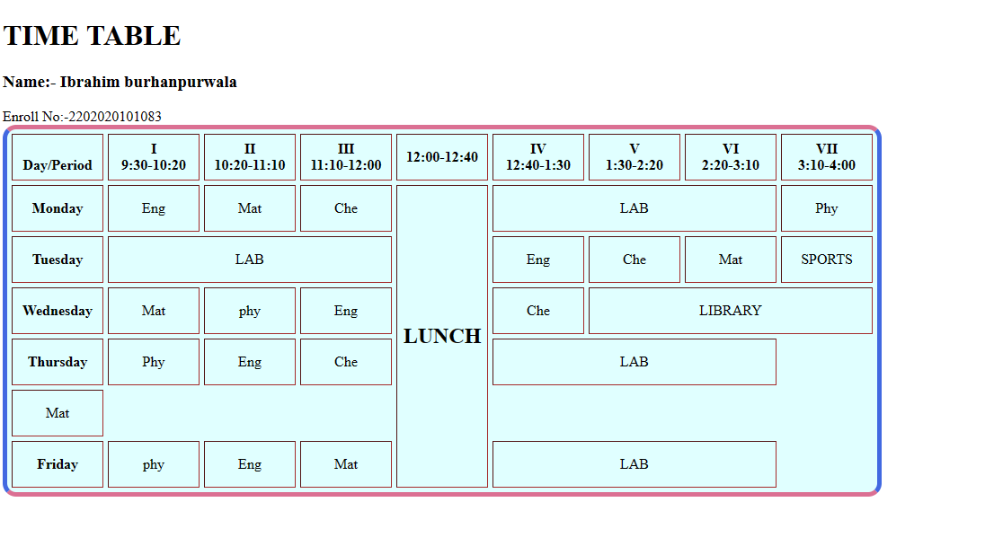

**5. Write a HTML Code for Application Form?**

<!DOCTYPE html>

<html>

<body>

<style>

table,

td,

th,

tr {

border-color: brown;

text-align: center;

padding: 0px;

}

table {

border: 5px solid palevioletred;

border-left: 6px solid royalblue;

border-right: 6px solid royalblue;

background-color: lightcyan;

border-radius: 15px;

border-style: solid 10px;

border-width: 5px

}

table {

background-color: beige;

box-shadow: 5px 5px 5px blue;

border: 1px solid green;

background-origin: 10px 10px 10px 10px;

font-family: 'Franklin Gothic Medium', 'Arial Narrow', Arial, sans-serif;

}

input,

select {

height: 30px;

radius: 10px 10px;

color: palevioletred;

}

border- input:hover,

select:hover {

height: 30px;

radius: 10px 10px;

color: burlywood;

}

#gender {

height: 30px;

width: 30px;

border-color: blanchedalmond;

color: blueviolet;

}

footer {

height: 60px;

background-color: rgb(19, 19, 21);

color: white;

text-align: center;

}

</style>

<!DOCTYPE html>

<html lang="en">

<head>

<meta charset="UTF-8">

<meta name="viewport" content="width=device-width, initial-scale=1.0">

<title>Document</title>

</head>

<body <h1 style="text-align: center;">application form</h1>

<from name="ff" method="post">

<h1>personal</h1>

<table border="0" width="500" height="200">

<tr>

<th>

application full name </th>

<td>

<input type="text" name="fname" placeholder="enter name" value="">

</td>

<tr>

<th> father's name </th>

<td>

<input type="text" name="father name" placeholder="enter father name" value="">

</td>

</tr>

<tr>

<th>

motherr's name </td>

<td>

<input type="text" name="mother name" placeholder="enter mother name" value="">

</td>

</tr>

<th> birth

date of </th>

<td>

<input type="date" name="birthday">

</td>

<tr> `

<th> gender </th>

<td>

<input type="radio" name="gender" value="male">male

<input type="radio" name="gender" value="female">female

<input type="radio" name="gender" value="other">other

</td>

</tr>

<tr>

<th>

marital status

</th>

<td>

<select>

<option value="">----select---</option>

<option value="one">one</option>

</select>

</td>

</tr>

<tr> `

<th>

handicapped

</th>

<td>

<input type="radio" name="handicapped" value="yes">yes

<input type="radio" name="handicapped" value="no">no

</td>

</tr>

<th>

care of

</th>

<td>

<input type="radio" name="care off" value="parents">parent

<input type="radio" name="care off" value="gardin">gardin

</td>

<tr>

<th>

categary

</th>

<td>

<select>

<option value="">----select---</option>

<option value="one">one</option>

</select>

</td>

</tr>

<tr>

<th>

Ex-servicemam

</th>

<td>

<input type="radio" name="ex" value="yes">yes

<input type="radio" name="ex" value="no">no

</td>

<tr>

<th>

religion

<td>

<select>

<option value="">----select---</option>

<option value="one">one</option>

</select>

</td>

</tr>

</th>

</table>

</from>

<from name="ff" method="post">

<legend>

contact details

</legend>

<table border="30" width="500" height="200">

<tr>

<th>

mobile number

</th>

<td>

<input type="number" name="no" placeholder="enter number" value="">

</td>

</tr>

<th>

email

</th>

<td>

<input type="text" name="em" placeholder="enter email" value="">

<tr>

<th>

address line 1

</th>

<td>

<input type="number" name="add" placeholder="enter address" value="">

</td>

</tr>

<th>

address line 2

</th>

<td>

<input type="number" name="add" placeholder="enter address" value="">

</tr>

</td>

<tr>

<th>

city

</th>

<td>

<input type="text" name="city" placeholder="enter city" value="">

</td>

</tr>

<tr>

<th>

pin code

</th>

<td>

<input type="number" name="pin" placeholder="enter pin code" value="">

</td>

</tr>

</table>

</from>

<from name="ff" method="post">

<legend>

qualification details

</legend>

<table border="0" width="500" height="200">

<tr>

<th>

sr.no

</th>

</tr>

<tr>

<th>

1

</th>

<td>

<select>

<option value="">----select---</option>

<option value="one">one</option>

</select>

<tr>

<th>

2

</th>

<td>

<select>

<option value="">----select---</option>

<option value="one">one</option>

</select>

<tr>

<th>

3

</th>

<td>

<select>

<option value="">----select---</option>

<option value="one">one</option>

</select>

<tr>

<th>

4

</th>

<td>

<select>

<option value="">----select---</option>

<option value="one">one</option>

</select>

</th>

</tr>

</table>

</from>

<from name="ff" method="post">

<H1>

language

</H1>

<table border="0" width="500" height="200">

<tr>

<th>

language

</th>

</tr>

<tr>

<th>

hindi

</th>

<td>

<input type="checkbox" name="urdu" value="reading">reading

<input type="checkbox" name="urdu" value="writing">writin

<input type="checkbox" name="urdu" value="spoken">spoken

</td>

</tr>

<tr>

<th>

english

</th>

<td>

<input type="checkbox" name="urdu" value="reading">reading

<input type="checkbox" name="urdu" value="writing">writing

<input type="checkbox" name="urdu" value="spoken">spoken

</tr>

</td>

<tr>

<th> urdu

</th>

<td>

<input type="checkbox" name="urdu" value="reading">reading

<input type="checkbox" name="urdu" value="writing">writing

<input type="checkbox" name="urdu" value="spoken">spoken

</td>

<tr>

</table>

</from>

<from name="ff" method="post">

<h1>

identification details

</h1>

<table border="0" width="500" height="100">

<tr>

<th> aadhar card

number

</th>

<td>

<input type="number" name="no" placeholder="enter number" value="">

</td>

</tr>

<tr> `

<th>

upload photo

</th>

<td>

<input type="number" name="no" placeholder="choose file" value="">

</td>

</tr>

<tr>

<th>

pan card number

</th>

<td>

<input type="number" name="no" placeholder="enter number" value="">

</td>

</tr>

<tr>

<th>

uplode singture </th>

<td>

<input type="number" name="no" placeholder="uplode singture" value="">

</td>

</tr>

</table>

<input type="submit" name="sub" value="submit"> <input type="reset" name="res" value="clear">

</from>

</table>

<footer>

<p>& copyright ibrahim burhanpurwala</p>

<p>enrolement no. 2202020101083</p>

</footer>

</body>

</html>

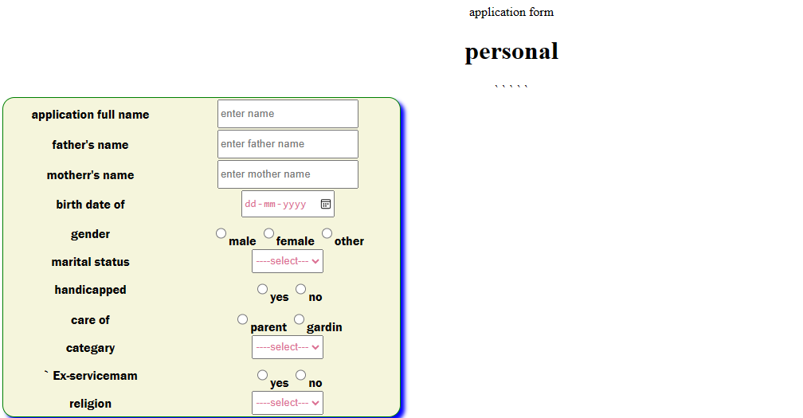

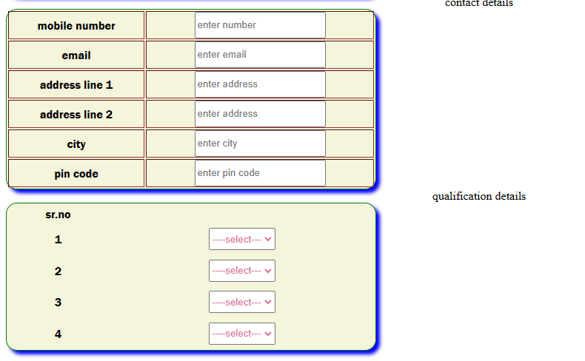

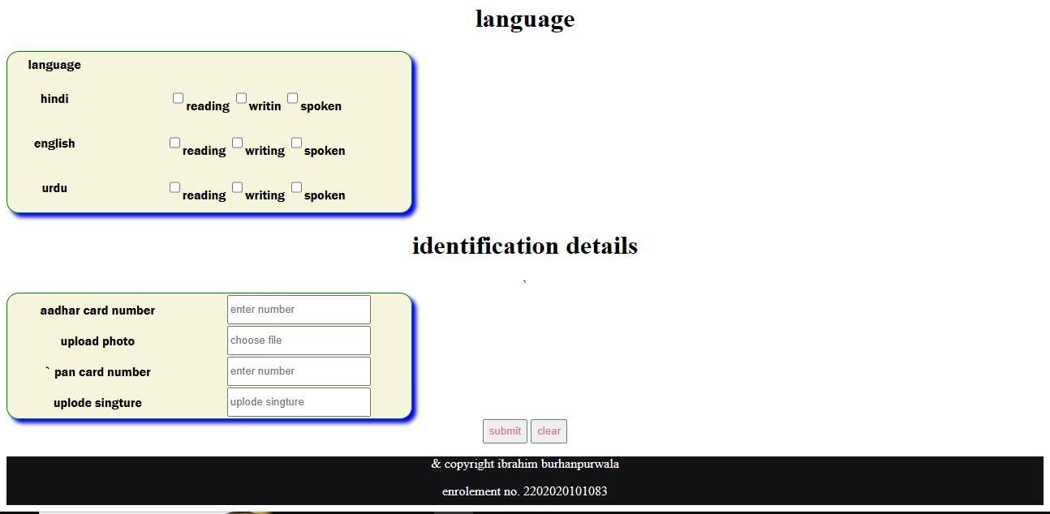

**6. Create a Demo Website using HTML Code? Webpage Contains below given Page**

<!DOCTYPE html>

<html lang="en">

<head>

<meta charset="UTF-8">

<meta name="viewport" content="width=>, initial-scale=1.0">

<title>Document</title>

</head>

<style>

body {

background-color: pink;

}

h1,

h3

color: red;

}

p,

ol {

color: green;

}

.header {

margin-right: 50px;

margin-left: 40px;

text-align: right;

}

hr {

height: 5px;

background-color: red;

}

.head {

align: center;

}

</style>

<body>

<div calss="header">

<h1>bhagavan mahavir college of computer application</h1>

<h3 class="head">detalis about bca...</h3>

<p class="head">bca is a course of computer application.<br><br>

bca is a professional course.<br><br>

if you choose bca than it's

right choice for ypou carrer.

</p>

</div>

<hr>

<div>

<h3>rules of bhagavan mahavir college...</h3>

<ol type="1">

<li>be regular in the college.</li>

<li>behave your self.</li>

<li>here no is compulsory.</li>

</ol>

</div>

</body>

</html>

Contactus page

<!DOCTYPE html>

<html lang="en">

<head>

<meta charset="UTF-8">

<meta name="viewport" content="width=>, initial-scale=1.0">

<title>Document</title>

</head>

<style>

input,

select,

textarea {

background-color: lightblue;

border-color: brown;

color:

black;

}

body {

background-color: lightblue;

}

tr,

td {

padding: 20px;

color: lightblue;

color: black;

}

</style>

<body>

<table border="1" width="500" height="500">

<tr>

<td><input type="text" placeholder="first name"></td>

</tr>

<tr>

<td><input type="text" placeholder="last name"></td>

</tr>

<tr>

<td><input type="email" placeholder="email"></td>

</tr>

<tr>

<td><input type="text" placeholder="Subject"></td>

</tr>

<tr>

<td><input type="message" placeholder="your message"></textarea></td>

</tr>

<tr>

<td><input type="submit" placeholder="submit"></td>

</tr>

</table>

</body>

</html>

<body an="center" style="color:red;background-color:skyblue;">

<p>

</p>

<p style="padding-left: 450px">

Name:-Ibrahim Burhanpurwala</p>

<p style="padding-left: 450px">Enroll NO:-2202020101083</p>

</body>

Header page

<!DOCTYPE html>

<html lang="en">

<head>

<meta charset="UTF-8">

<meta name="viewport" content="width=device-width, initial-scale=1.0">

<title>Document</title>

</head>

<style>

img {

float: right;

border: 1px dotted black;

margin: 0px 0px 15px 20px;

}

div {

position: fixed;

bottom: 15px;

right: 50px;

.zoom:hover {

transform: scale(1.5);

}

</style>

<body scroll="no" style="overflow: hidden;background-color:skyblue;">

<p style align="right" style="color:red; font-size:40pt;margin: right 40%;">

<img src="logo.png" class="zoom" style="float: left;width: 80px;height:

80px;"><br>

<h2>

<center>demo website</center>

</h2></b>

<small style="font-size: 15pt;color: white;">

<center>knowledge is life.</center>

</small></p>

<div>

<a href="login.html" target="_top">logout</a>

</div>

</body>

</html>

Demo page

<!DOCTYPE html>

<html lang="en">

<head>

<meta charset="UTF-8">

<meta name="viewport" content="width=>, initial-scale=1.0">

<title>Document</title>

</head>

<body>

<base target="main">

<a href="about.html"><img src="dem.png"></a><br><br><br>

</body>

</html>

Login page

<!DOCTYPE html>

<html lang="en">

<head>

<title>login</title>

<link rel="stylesheet" href="style1.css">

</head>

<body> <img alt="logo" src="logo.jpg" class="center">

<from name="login" onsubmit="return vaildateForm()"> username<br> <input type="password" name="pass"><br><br>

<input type="submit" value="login">

</from>

</body>

<script> function validateForm() {

let x = document.forms["login"]["user"].value;

let y = document.forms["login"]["pass"].value; if (x == "BMU" & y == "BMU"); return false

}

{

alert("enter detalis");

} </script>

</html>

